**2015-16 Quantitative Literacy ILO Assessment**

**Summary of Efforts and Progress as of February 2016**

**Stephen Contakes, Ray Rosentrater, and Enrico Manlapig, QL ILO Assessment Team**

**What are our aims?**

The present project seeks to assess scope and adequacy of Westmont’s Quantitative Literacy (QL) ILO:

**QL ILO:** “Graduates of Westmont College will apply relevant scientific, mathematical and logical methods to analyze and solve problems effectively and be able to utilize the results appropriately when making decisions (Quantitative Literacy)”

As part of this effort the closely-aligned Quantitative & Analytical Reasoning (QAR) GELO will also be assessed:

**QAR GELO:** Students will apply relevant scientific, mathematical and logical methods to analyze and solve problems effectively and be able to utilize the results appropriately when making decisions.

We will use our experiences assessing the QL ILO and QAR GELO to develop more effective, streamlined, and sustainable assessment efforts for these areas.

**What is our assessment plan and how is it being implemented?**

Our plan to assess the scope and impact of quantitative literacy education at Westmont was to:

1. Evaluate the alignment between the QL ILO and the scope, quality, and impact of the courses offered in the Quantitative and Analytical Reasoning (QAR) GE category (appendices 1-5) as well as student’s self-reporting of engagement with quantitative reasoning on the appropriate items on the National Survey of Student Engagement (NSSE) (appendix 6).
2. Assess the overall impact of quantitative literacy education at Westmont by comparing the quantitative reasoning abilities of
   * seniors and incoming first year and transfer students (appendix 7)
   * students completing and entering Westmont QAR courses (appendix 8)

using the Quantitative Literacy Reasoning Assessment (QLRA) test.

1. Assess how a Westmont education impacts students’ perspectives on quantitative reasoning by comparing senior and incoming first year and transfer students’ attitudes towards quantitative reasoning as assessed by the supplemental questions on the QLRA test (Appendix 9)

**What have we learned so far and how have we attempted to close the loop?**

A summary of the detailed assessment plan and our current progress in implementing it is outlined in Table 1.

**Table 1.** Summary of aspects of quantitative literacy that were or will be assessed in the 2015-16 QL ILO assessment.

|  |  |  |  |
| --- | --- | --- | --- |
| *What will be assessed?* | *How?* | *What did we learn?* | *What did we do?* |
| The scope and adequacy of quantitative literacy education inputs at Westmont? Specifically, whether our QAR GE category is adequate in terms of the number and range of courses represented, and the intended pervasiveness and rigor of QL in a Westmont education. | The adequacy of Westmont’s quantitative and analytical reasoning (QAR) GE Learning Outcome (GELO) was assessed in discussions among the instructors of QAR courses and by comparing the existing GELO with the literature on quantitative literacy education. | The pre-2015 QAR GE Learning Outcome (GELO) and course certification criteria did not adequately emphasize the use of quantitative reasoning in problem solving. | The QL ILO, QAR GELO, and QAR course certification criteria were changed in the Spring of 2015 to better emphasize our desire that students grow in their ability to employ quantitative literacy in problem solving applications. |
| The disciplinary scope and availability of QAR approved GE courses was reviewed. | There are adequate QAR offerings among the lower division science, computer science and math courses but relatively few in the humanities and social sciences, partly because these students either take the math statistics course or meet the GE through an elective. We also learned that there are few upper division QAR courses. | These findings were presented to the GE committee, academic senate, and full faculty. Other actions are pending GE committee, senate, and whole faculty discussion of the QAR assessment results and more work may be needed to assess the pervasiveness of quantitative literacy content in upper division and major courses. |
| A survey of 2015 graduate data was undertaken to determine how our students meet the QAR GE Requirement? | Most students (~90%) meet the QAR GE requirement through a Westmont course. In addition, 38% of students meet the QAR GE requirement through a major-required course. | These findings were presented to the GE committee, academic senate, and full faculty. While our ultimate course of action is pending GE committee, senate, and whole faculty discussion of the QAR assessment results, the consensus so far is that the pervasiveness of QAR in upper division and major courses is possibly a greater area of concern. |

**Table 1 (continued).** Summary of aspects of quantitative literacy that were or will be assessed in the 2015-16 QL ILO assessment.

|  |  |  |  |
| --- | --- | --- | --- |
| *What will be assessed?*  *(continued)* | *How?* | *What did we learn?* | *What did we do?* |
| The scope and adequacy of quantitative literacy education inputs at Westmont? Specifically, whether our QAR GE category is adequate in terms of the number and range of courses represented, and the intended pervasiveness and rigor of QL in a Westmont education. (Continued) | The GE committee undertook a QAR syllabus review to evaluate the extent to which these documents evidenced a rigorous and pervasive approach to quantitative literacy. | There appears to be a high degree of instructor support for the QAR GE category, although there is room for improvement in terms of our expectations for how effectively instructors explain how their course meets the QAR GE certification criteria, especially with respect to assessing quantitative models as tools in the natural and social sciences. | These findings were presented to the GE committee. Pending GE committee, senate, and whole faculty discussion of the QAR assessment results as well as further faculty discussion on expectations for syllabi and how they should be taught and enforced. |
| Senior and first year responses to the three quantitative literacy questions on the National Survey of Student Engagement (NSSE) were reviewed. These questions ask students about the frequency with which they engage in quantitative literacy and reasoning tasks. | Westmont students perceive themselves to engage in quantitative reasoning about as often as other CCCU students and as often as or slightly less often than their peers at other California and US institutions. | These findings were presented to the GE committee, academic senate, and full faculty. While our ultimate course of action is pending GE committee, senate, and whole faculty discussion of the QAR assessment results, the consensus so far is that student engagement with quantitative reasoning can be improved by addressing the other issues identified in this assessment. |

**Table 1 (continued).** Summary of aspects of quantitative literacy that were or will be assessed in the 2015-16 QL ILO assessment.

|  |  |  |  |
| --- | --- | --- | --- |
| *What will be assessed?*  *(continued)* | *How?* | *What did we learn?* | *What did we do?* |
| The quantitative literacy (QL) of our incoming students, specifically our incoming students’ aptitudes, weaknesses, and attitudes. | The Bowdoin College-developed Quantitative Literacy Reasoning Assessment (QLRA) test was administered to incoming first year and transfer students in order to assess their quantitative literacy competency and attitudes towards quantitative literacy. | Our incoming students’ quantitative literacy abilities exhibit a bimodal distribution. Both the proportion of students in the lower distribution and the aggregate mean score indicate our student population possesses quantitative literacy and reasoning aptitudes intermediate between those of their peers at selective and non-selective four-year schools. Incoming students exhibit greater proficiency with general skills like rounding but more poorly on specific skills like working with percentages, reading graphs, and algebra. | These findings were presented to the GE committee, academic senate, and full faculty. Although our ultimate course of action is pending GE committee, senate, and whole faculty discussion of the entire set of QAR assessment results, the current recommendation is that faculty be encouraged to redress the identified student weaknesses in their courses as they are able. Otherwise more action is not recommended at this time since the senior-first year comparison indicates that our students already exhibit considerable improvement in the areas of greatest deficiency. |
| The attitudinal supplemental questions of the QLRA test were used to determine our incoming students’ attitudes towards quantitative literacy. | Incoming students exhibited an overall positive attitude towards quantitative literacy, although they were ambivalent about the question asking about the importance of numerical information for most situations. | Although our ultimate course of action is pending GE committee, senate, and whole faculty discussion of the QAR assessment results, the current recommendation is that no action be taken at this time, especially given the vagueness of the question about numerical information’s usefulness for “most situations” and the importance of both quantitative and non-quantitative modes of reasoning for decision making. |

**Table 1 (continued).** Summary of aspects of quantitative literacy that were or will be assessed in the 2015-16 QL ILO assessment.

|  |  |  |  |
| --- | --- | --- | --- |
| *What will be assessed?*  *(continued)* | *How?* | *What did we learn?* | *What did we do?* |
| How effective is QL education in Westmont’s curriculum, both in terms of individual courses and a Westmont education as a whole. | The effectiveness of a Westmont education as a whole in promoting quantitative literacy was assessed by administering the QLRA to seniors in January 2016 and comparing the results with those for incoming students. | Overall, seniors did considerably better than incoming students and exhibited improvements in most skill categories. The largest increases occurred for students’ ability to use algebra, interpret pie charts, understand verbally represented problems, work with percentages, interpret tables, and engage in proportional reasoning. A small decrease was observed for students’ ability to use histograms. | This is unsurprising, given that most of the courses that Westmont students use to complete the QAR GE fall in the areas of physical science, calculus, discrete mathematics, and computer science and do not feature extensive use of histograms. These findings will be discussed with the GE committee, senate, and whole faculty discussion in order to determine what actions, if any, are needed to redress our students’ loss of aptitude in interpreting histogram data. |
| The effectiveness of individual courses was determined by pre- & post- course assessment of students enrolled in courses meeting the QAR GE requirement in the fall of 2015. | The pre- and post- course data for fall 2015 QAR GE courses is still being assessed. Preliminary indications are that students did marginally better after completing a QAR GE course but that the data may be marred by a significant number of “randomly completed” QLRA tests. | This issue should be revisited in a future round of assessment in which students are (a) asked to complete the post-course QLRA assessment over winter break rather than during the busy period at the end of the semester and (b) offered financial incentives for good faith completion of the QLRA, perhaps by holding an amazon gift card drawing similar to that used in the senior assessment. |
| The impact of a Westmont education on students’ attitudes towards quantitative literacy was assessed using the supplemental questions on the QAR exam. | Comparison of senior and incoming student data revealed that both exhibited very positive attitudes towards quantitative literacy. However, senior attitudes tended to be slightly more positive overall, in part because fewer exhibited strongly negative attitudes towards quantitative literacy. | While our ultimate course of action is pending GE committee, senate, and whole faculty discussion of the QAR assessment results, the consensus so far is that the increase in overall student appreciation of quantitative reasoning is adequate, especially that a liberal arts education appropriately stresses the importance of both numerical and non-numerical information and methodologies. |

**Additional notes about what we have we learned so far…**

*…about the scope and adequacy of QL education at Westmont*

1. Westmont has 21 QAR GE courses (Appendix 2), of these

* 19 are in the natural and behavioral sciences and two in the social sciences
* 17 are offered during the 2015-16 academic year, sixteen in the natural sciences and one in the social sciences
* 11 are offered in the fall of 2015; of these seven administered the QLRA assessment as a course pretest.

1. Westmont students meet the QAR GE requirement:

* Through a QAR-approved course within their major (38% of students): QAR courses are required as part of the major requirements of 14 Westmont’s 27 majors (Appendix 3). A survey of the 2015 graduates (Appendix 4) indicates that **38%** (118 of 307) completed a major that required one or more QAR courses as part of the major program.
* Through a QAR elective GE course (62% of students): Of the 2015 graduates, 61% (189 of 307) completed one or more majors, none of which required a QAR course as part of the major program. The breakdown for how these completed the QAR requirement is as follows:
  + 85.5% through Westmont coursework
  + 4.5% through AP credit
  + 10.0% through transfer credit

The most popular Westmont elective QAR courses used to meet the QAR requirement were in the physical sciences and computer science (e.g. PHS-007 (20.6%), PHS-011 (15.87%), CS-005 (15.87%), and PHY-017 (12.7%)).

* A review of QAR course syllabi (appendix 5) indicated a high degree of instructor commitment to the QAR GE. Instructors consistently identified their courses as meeting the QAR requirement, attempted to explain why the course met the QAR requirement, and aligned their course learning outcomes with the QAR GE learning outcomes. Based on the livetext rubric assessment used, instructors demonstrated less compliance with the syllabus guidelines and did not as consistently demonstrate the degree to which their courses asked students to reflect on the strengths and weaknesses of quantitative models as tools in the natural and behavioral sciences. However, a detailed evaluation of the syllabi indicates that the former issue was not directly relevant to the QAR GE category while the latter may reflect the stylistic conventions of science syllabi. Specifically, science syllabi often reference the textbook when describing course assignments and so do not typically do not include enough detail in the syllabus itself to adequately communicate the degree to which quantitative models are evaluated.

1. Westmont students’ answers to the NSSE quantitative literacy questions (Appendix 6) indicate that they perceive themselves to engage in quantitative reasoning about as often as other CCCU students and as often as or slightly less often than their peers at other California and US institutions.

*…about our incoming students’ aptitudes, weaknesses, and attitudes.*

1. Our incoming students’ QLRA results (Appendix 7) indicate that their quantitative literacy abilities exhibit a bimodal distribution with means of 34% (48% of students) and 70% (52% of students). Both the proportion of students in the lower distribution and the aggregate mean score of 52±2% (e.s.d. 22%, n = 107) indicate our student population possesses quantitative literacy and reasoning aptitudes intermediate between those of their peers at selective (59.7% mean) and non-selective (30.1% mean) four-year schools.
2. Incoming students exhibit greater proficiency with general skills like rounding but more poorly on specific skills like working with percentages, reading graphs, and algebra.
3. Incoming students exhibited an overall positive attitude towards quantitative literacy. The only possible item of concern is their ambivalence about the question asking about the importance of numerical information for most situations. However, this is not regarded as an area of concern both because that question is vaguely worded and because non-quantitative factors and modes of reasoning can indeed be determinative in many situations.

*How effective a Westmont education is at developing quantitative literacy appreciation and competency.*

1. Seniors’ results on the Quantitative Literacy and Reasoning Assessment (QLRA) test are summarized in Appendix 7. Overall, seniors did considerably better than incoming students. Seniors achieved an average score of 64± 1 % (e.s.d. = 24%, n = 81) at the 95% confidence level and exhibited improvements in most skill categories. The largest increases occurred for students’ ability to use algebra, interpret pie charts, understand verbally represented problems, work with percentages, interpret tables, and engage in proportional reasoning. A small decrease was observed for students’ ability to use histograms. This is unsurprising, given that most of the courses that Westmont students use to complete the QAR GE fall in the areas of physical science, calculus, discrete mathematics, and computer science and do not feature extensive use of histograms. Seniors exhibited significantly more positive attitudes towards quantitative literacy than incoming students, although seniors tended to be polarized over the question of whether numerical information is necessary in most situations. This may be due to the vagueness of that question but also might reflect some seniors’ better awareness that some situations are not easily reduced to a quantitative reasoning problem.
2. QAR pre-/post course comparison data is still being compiled and will be added to Appendix 8 when it is available.

**Additional notes about our recommendations for improving Westmont’s effectiveness at quantitative literacy education and other closing the loop activities.**

Preliminary results for our assessment of Westmont’s curricular offerings and incoming student attitudes were presented to the GE committee, academic senate, and full faculty. When available the final results of this study will be reviewed in the late spring and fall of 2016 in order to develop recommendations as to how we might improve our efforts in this area. As of February 2016, it seems that our students seem to be meeting the objectives of the QL ILO but we might benefit from some adjustments to our QAR GE course offerings, QAR course syllabus policies, incorporation of histograms in QAR instruction, and our strategy for implementing value added assessment of QAR GE courses.

**Appendix 1: GE Combined Document Description of the *Quantitative and Analytical Reasoning* Common Skills GE.**

**Quantitative and Analytical Reasoning** (4)

Since many phenomena in our world can best be understood through quantitative and analytic methods, students should develop the ability to interpret, evaluate and communicate quantitative ideas. Central to courses satisfying this requirement is: the use of mathematical models for physical or social systems or; the understanding and communication of numeric data including the computation and interpretation of summative statistics and the presentation and interpretation of graphical representations of data. A core focus of the course should be the explicit study of quantitative and analytic methods, or, alternatively, the reflective use of quantitative methods as a tool.

**Certification Criteria**

Students will be able to

1. make use of mathematical (including statistical)models for physical or social systems

-and/or-

compute and interpret numeric data, summative statistics and/or graphical representations;

*2.* reflect on the strengths and weaknesses of particular quantitative models or methods as tools in the natural and social sciences;

3. be able to interpret, reflect on, and use quantitative models and data in public, vocational, and/or private decision making.

**Student Learning Outcome** (assessed as part of Quantitative Reasoning ILO)

Students will apply relevant scientific, mathematical and logical methods to analyze and solve problems effectively and be able to utilize the results appropriately when making decisions.

**Appendix 2: Westmont Quantitative and Analytical Reasoning GE Courses**

**Key:**

* **Green** means that the course is offered in both the **fall of 2015 and spring of 2016**
* **Red** means that the course is offered in the **fall of 2015**
* **Blue** means that the course is offered in the **spring of 2016**
* **An asterisk (*)** means that at least one section of the course **participated in the fall 2015 pretest assessment.** Courses were counted as having participated if they attained a response rate greater than 15%, although for reference the participating course response rate varied between 27 and 100% while the nonparticipating response rate varied from 2-8%.
* **A double dagger (‡)** means that the course has not been offered recently (>5 years) and that there is no immediate plans to offer it in the future.

**‡CHM-001 Introductory General Chemistry**

**\*CHM-005 General Chemistry I w/ Lab**

**CS-005 Fundamentals of Computing**

**\*CS/MA-015 Discrete Mathematics**

**MA-004 Mathematics in Context**

**\*MA-005 Statistics**

**‡MA-007 Finite Mathematics**

**\*MA-008 Functions and Models**

**\*MA-009 Calculus I**

**\*MA-010 Calculus II**

**MA-019 Multivariable Calculus**

**MA-165 Fundamentals of Mathematics II**

**PHS-007 Astronomy: Discovering the Universe**

**PHS-011 Introduction to Physical Science**

**PHS/PHY-017 Physics of Music**

**PHY-011 Physics for Life Sciences I**

**PHY-013 Physics for Life Sciences II**

**\*PHY-021 General Physics I: Mechanics and Heat**

**PHY-023 General Physics II: Electricity, Magnetism and Light**

**POL-040 Empirical Political Research**

**SOC-107 Qualitative and Quantitative Analysis with Lab**

**Appendix 3: Quantitative and Analytical Reasoning GE Courses in Westmont Major Programs**

*Westmont majors that require one or more QAR GE courses as part of the major program*

[Biology (B.A., B.S.)](http://www.westmont.edu/_academics/departments/biology/)

[Chemistry](http://www.westmont.edu/_academics/departments/chemistry/)   
[Computer Science (B.A., B.S.)](http://www.westmont.edu/_academics/departments/computer_science/)  
[Economics & Business (B.A.)](http://www.westmont.edu/_academics/departments/economics_business/)  
[Engineering Physics (B.A., B.S.)](http://physics.westmont.edu)   
[Kinesiology (B.S.)](http://www.westmont.edu/_academics/departments/kinesiology/)

[Liberal Studies (B.A.)](http://www.westmont.edu/_academics/departments/education/)

[Mathematics (B.A., B.S.)](http://www.westmont.edu/_academics/departments/mathematics/)

[Music Education (B.M.E.)](http://www.westmont.edu/_academics/departments/music/)   
[Physics (B.A., B.S.)](http://www.westmont.edu/_academics/departments/physics/)  
[Political Science (B.A.)](http://www.westmont.edu/_academics/departments/political_science/)

[Psychology (B.A., B.S.)](http://www.westmont.edu/_academics/departments/psychology/)   
[Social Science (B.A.)](http://www.westmont.edu/admissions/academics.html#social)

[Sociology (B.A.)](http://www.westmont.edu/_academics/departments/sociology_anthropology/)

*Westmont majors that do not require one or more QAR GE courses as part of the major program*

[Art (B.A.)  
Art History (B.A.)](http://www.westmont.edu/_academics/departments/art/)[Communication Studies (B.A.)](http://www.westmont.edu/_academics/departments/communication_studies/)

[English (B.A.)](http://www.westmont.edu/_academics/departments/english/)  
[European Studies (B.A.)](http://www.westmont.edu/_offices/registrar/documents/Catalog.pdf)  
[French (B.A.)](http://www.westmont.edu/_academics/departments/modern_languages/french.html)

[History (B.A.)](http://www.westmont.edu/_academics/departments/history/)

[Interdisciplinary (B.A., B.S.)](http://www.westmont.edu/_offices/registrar/academic_policies/interdisciplinary-majors-policy.html)  
[Music (B.A.)](http://www.westmont.edu/_academics/departments/music/)   
[Philosophy (B.A.)](http://www.westmont.edu/_academics/departments/philosophy/)

[Religious Studies (B.A.)](http://www.westmont.edu/_academics/departments/religious_studies/)

[Spanish (B.A.)](http://www.westmont.edu/_academics/departments/spanish/)

[Theatre Arts (B.A.)](http://www.westmont.edu/_academics/departments/theatre_arts/)

**Appendix 4: How the 62% of 2015 Westmont graduates without a major-required QAR course attained the QAR requirement**

**Table A4-1.** Overall breakdown

|  |  |
| --- | --- |
| **Method** | **%** |
| Westmont Coursework | 85.5 |
| Transfer Credit | 10.0 |
| AP Credit | 4.5 |

**Table A4-2.** Westmont courses used to complete the QAR GE.

|  |  |  |  |  |
| --- | --- | --- | --- | --- |
| Course |  | Title | # Students | % students |
| CHM 5/5H |  | General Chemistry I w/ Lab | 10 | 5.29% |
| CS-005 |  | Fundamentals of Computing | 30 | 15.87% |
| CS-015 |  | Discrete Mathematics | 1 | 0.53% |
| MA-004 |  | Mathematics in Context | 16 | 8.47% |
| MA-005 |  | Statistics | 17 | 8.99% |
| MA-008 |  | Functions and Models | 1 | 0.53% |
| MA-009 |  | Calculus I | 13 | 6.88% |
| MA-010 |  | Calculus II | 1 | 0.53% |
| MA-019 |  | Multivariable Calculus | 2 | 1.06% |
| MA-165 |  | Fundamentals of Mathematics II | 1 | 0.53% |
| PHS-007 |  | Astronomy: Discovering the Universe | 39 | 20.63% |
| PHS-011 |  | Introduction to Physical Science | 30 | 15.87% |
| PHY-017 |  | Physics of Music | 24 | 12.70% |
| PHY-011 |  | Physics for Life Sciences I | 2 | 1.06% |
| PHY-021 |  | General Physics I: Mechanics and Heat | 1 | 0.53% |
| PHY 1110 |  | Introduction to the Natural Sciences (although this may be a transfer course that was miscoded as a Westmont course) | 1 | 0.53% |
| Total |  |  | 189 | 100.00% |

**Appendix 5: Results of the fall 2015 review of syllabi for courses meeting Westmont’s Quantitative and Analytical Reasoning (QAR) GE requirement.**



**Appendix 6: 2014 Westmont NSSE Survey Statistical Comparisons Results**

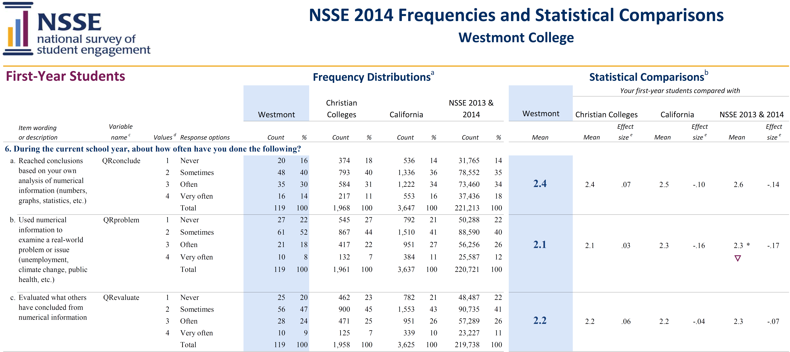

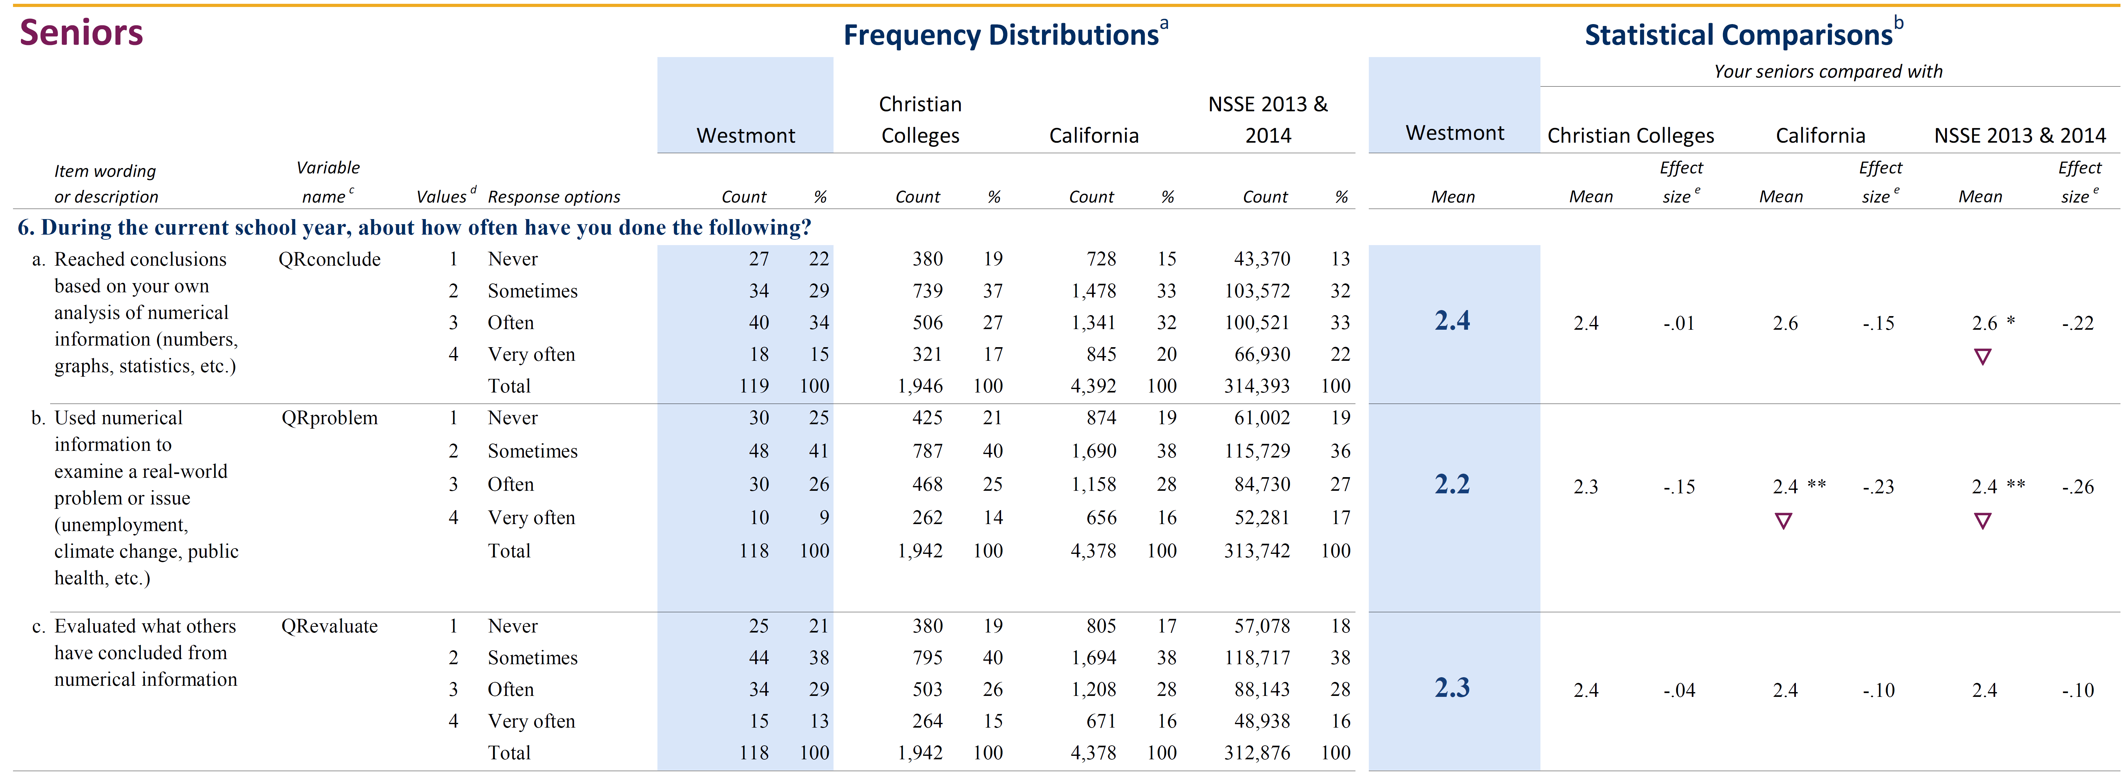

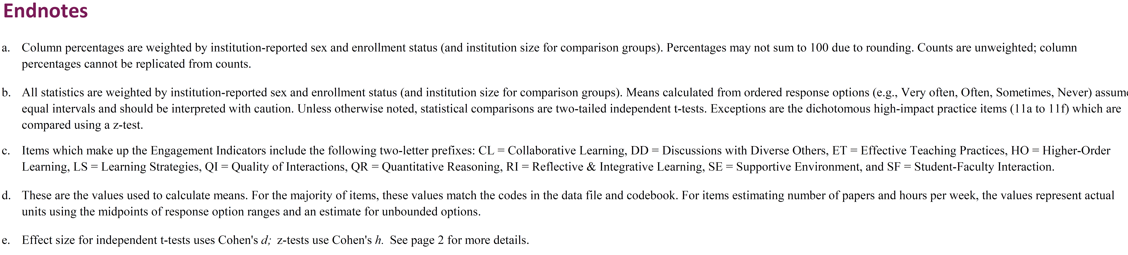

**Appendix 7: Senior and Incoming Student QLRA Assessment Comparisons**

**Figure A7-1.** Distribution of Quantitative Literacy and Reasoning Assessment (QLRA) scores for seniors and incoming students.

**Figure A7-2.** Skills exhibited by Westmont seniors and incoming students as assessed by the QLRA test.

**Appendix 8: Pre- and Post-QAR GE Course QLRA Assessment Comparisons**

QAR pre-/post course comparison data are still being compiled and will be added to Appendix 8 when it is available.

**Appendix 9: Westmont Student perspectives on the importance of quantitative reasoning as assessed by the QLRA supplemental questions.**

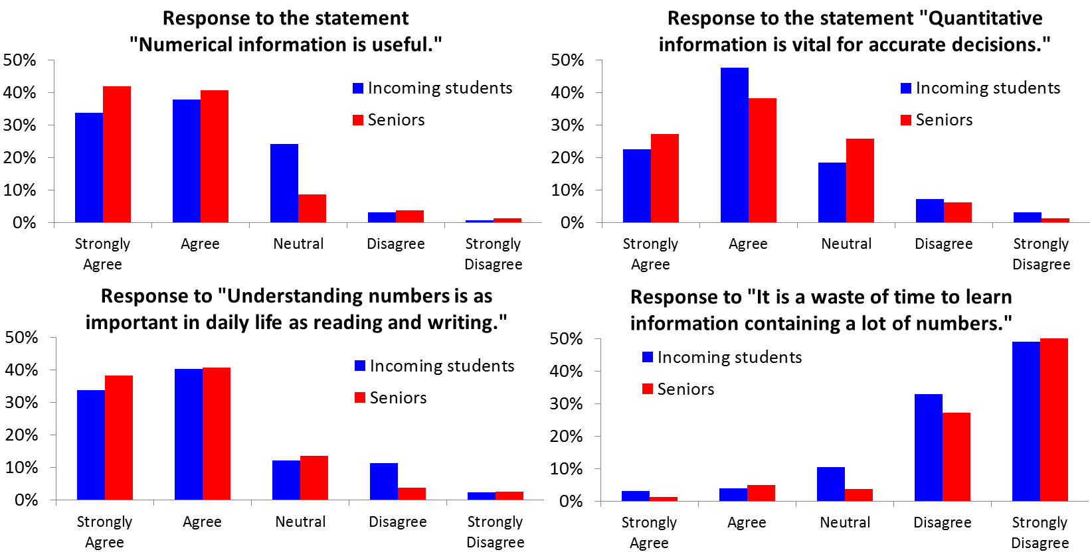

**Figure A9-1.** Responses to select QLRA supplemental questions.