2015-16 Quantitative Literacy ILO Assessment
Summary of Efforts and Progress as of February 2016

Stephen Contakes, Ray Rosentrater, and Enrico Manlapig, QL ILO Assessment Team

What are our aims?
The present project seeks to assess scope and adequacy of Westmont’s Quantitative Literacy (QL) ILO:

QL ILO: “Graduates of Westmont College will apply relevant scientific, mathematical and logical methods to analyze and solve problems effectively and be able to utilize the results appropriately when making decisions (Quantitative Literacy)”

As part of this effort the closely-aligned Quantitative & Analytical Reasoning (QAR) GELO will also be assessed:

QAR GELO: Students will apply relevant scientific, mathematical and logical methods to analyze and solve problems effectively and be able to utilize the results appropriately when making decisions.

We will use our experiences assessing the QL ILO and QAR GELO to develop more effective, streamlined, and sustainable assessment efforts for these areas.

What is our assessment plan and how is it being implemented?
Our plan to assess the scope and impact of quantitative literacy education at Westmont was to:

- Evaluate the alignment between the QL ILO and the scope, quality, and impact of the courses offered in the Quantitative and Analytical Reasoning (QAR) GE category and student’s self-reporting of engagement with quantitative reasoning on the appropriate items on the National Survey of Student Engagement (NSSE). The QL ILO, QAR GELO, and QAR course certification criteria were reviewed in the fall of 2014 and spring of 2015. A survey of Westmont’s QAR GE offerings, QAR GE course syllabi, and NSSE responses was completed over the period September to January 2016.

- Evaluate the overall impact of quantitative literacy education at Westmont by using the Quantitative Literacy Reasoning Assessment (QLRA) test to assess compare the quantitative reasoning abilities of
  - seniors and incoming first year and transfer students
  - students completing and entering Westmont QAR courses
The QLRA test was implemented on Westmont computer systems in the summer of 2015 and administered to incoming students in August and September 2015, students in QAR GE courses in September and December 2015, and seniors in January 2016. The data for incoming students and seniors have been compiled while that for pre- and post- QAR GE course testing is still being processed.

- Assess how a Westmont education impacts students’ perspectives on quantitative reasoning by comparing senior and incoming first year and transfer students’ attitudes towards quantitative reasoning as assessed by the supplemental questions on the QLRA test. As indicated under point 2 above, the data for incoming students and seniors have been compiled while pre- and post- QAR GE course data is still being processed.
Our preliminary findings have been reported to the GE committee, academic senate, and full faculty. Once the data collection and processing is complete we anticipate discussing our findings with the GE committee, faculty teaching QAR GE courses, Academic Senate, and full faculty in order to develop workable recommendations for improving our efforts towards achieving the QL ILO and QAR GELO.

What have we learned so far and how have we attempted to close the loop?
Documentation of our detailed findings is available by request. The following is a summary of our most important findings and actions so far. Note, however, that since this assessment is in-progress we still have some closing the loop activities to complete.
- Discussions among the instructors of QAR courses and comparison of the existing GELO with the literature on quantitative literacy education, suggested that our pre-2015 QAR GE Learning Outcome (GELO) and course certification criteria did not adequately emphasize the use of quantitative reasoning as a problem-solving tool. In response the QAR GELO and certification criteria were modified in the spring of 2015 to better emphasize our desire that students grow in their ability to employ quantitative literacy in problem solving applications.
- We currently offer an extensive range of QAR courses among the lower division science, computer science and math courses but relatively few in the humanities and social sciences, partly because these students either take the math statistics course or meet the GE through an elective. We also learned that there are few upper division QAR courses.
- A review of how our 2015 graduates met the QAR GE requirement indicated that most Westmont students meet the QAR GE requirement through a Westmont course (85.5%) or AP credit (4.5%). In addition, 38% of students meet the QAR GE requirement through a major-required course and 62% through an elective course. The most popular Westmont elective QAR courses used to meet the QAR requirement were in the physical sciences and computer science (e.g. PHS-007 (20.6%), PHS-011 (15.87%), CS-005 (15.87%), and PHY-017 (12.7%)).
- Our review of the syllabi of fall 2015 courses meeting the QAR GE requirement indicated a high degree of instructor awareness and appreciation for the QAR GE category, although there is room for improvement in terms of our expectations for how effectively instructors explain how their course meets the QAR GE certification criteria, especially with respect to assessing quantitative models as tools in the natural and social sciences.
- A review of our students’ responses to the NSSE questions dealing with QL indicate that Westmont students perceive themselves to engage in quantitative reasoning about as often as other CCCU students and as often as or slightly less often than their peers at other California and US institutions.
- Our incoming students’ quantitative literacy abilities as assessed by the QLRA exhibit a bimodal distribution with means of 34% (48% of students) and 70% (52% of students) (Figure 1). Both the existence of a lower distribution and the aggregate mean score of 52±2% (e.s.d. 22%, n = 107) indicate our student population possesses quantitative literacy and reasoning aptitudes intermediate between those of their peers at selective and non-selective four-year schools.
Figure 1. Comparison of incoming student and seniors' QLRA score distribution.
- Our incoming students exhibit greater proficiency with general skills like rounding but they do more poorly on specific skills like working with percentages, reading graphs, and algebra (Figure 2).
- Overall, seniors did considerably better than incoming students on the QLRA, with a mean score of 64± 1 % (e.s.d. = 24%, n = 81) and improvements in most skill categories. The largest increases occurred for students’ ability to use algebra, interpret pie charts, understand verbally represented problems, work with percentages, interpret tables, and engage in proportional reasoning. A small decrease was observed for students’ ability to use histograms.
- Our incoming students and seniors exhibited an overall very positive attitude towards quantitative literacy, with seniors exhibiting a slightly more positive attitude overall and lower rates of disagreement with statements about the importance of quantitative reasoning (Figure 3).
Figure 2. Skills exhibited by Westmont seniors and incoming students as assessed by the QLRA test.
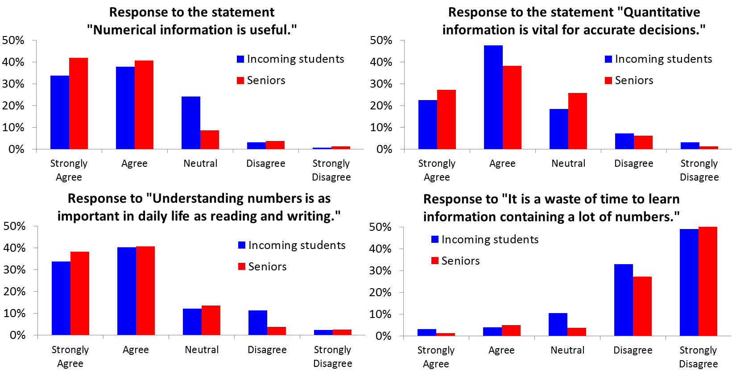
- The pre- and post- course data for fall 2015 QAR GE courses are still being compiled. Preliminary indications are that students did marginally better after completing a QAR GE course but that the data are marred by a significant number of “randomly completed” QLRA tests. Most likely that this round of testing will serve as the basis for a revised assessment plan, specifically one which students are asked to complete the post-course QLRA assessment over winter break instead of during the busy period at the end of the semester and offered financial incentives for good faith completion of the QLRA.

Figure 3. Student responses to select QLRA supplemental questions.

What is our tentative summary evaluation at this point?
In general our students seem to be meeting the objectives of the QL ILO but we might benefit from some adjustments to our QAR GE course offerings, QAR course syllabus policies, incorporation of histograms in QAR instruction, and our strategy for implementing value added assessment of QAR GE courses.

