**Appendix 1. Environmental Studies Student Survey Results (Spring 2018)**

**General Survey Design:**

A survey of interest in environmental studies was completed by 258 students enrolled in General Education (history, art, life sciences) and science courses (biology and chemistry majors). Students were asked to indicate (1) their class level, (2) whether they had encountered environmental issues in any Westmont courses, (3) whether they believed there was more need of treatment these issues at Westmont, (4) whether they would be interested in an introductory course, and (5) whether they would be interested in a minor (see appended survey questions).

**Overview of Findings:**

1. **42%** said they **had covered** some topic related to environment/sustainability and conservation at Westmont.
   1. Biology/chemistry students were significantly more likely to indicate they had covered such a topic (50%) than GE students (37%).
      1. For Biology/Chemistry students, they had primarily touched on such topics **briefly** in General Biology; the same was true for GE students, though in this case General Chemistry and International Politics were mentioned almost as frequently as General Biology.
   2. Second, third, and fourth year students were all equally likely to have covered such a topic at some point, but all of these were significantly more likely to have done so than first year students.
2. **83%** of students surveyed **saw greater need** for treatment of environmental issues in the Westmont curriculum.
   1. This did not vary between GE and Biology/Chemistry students or class level.
3. A total of **77%** said they would either “yes, very much” (33%) be interested in or ”strongly consider” (44%) taking an **introductory environmental studies course**.
   1. Biology/chemistry students were significantly more likely to say “yes, very much” (42%) than GE students (27%) rather than simply “consider” or outright “no” than GE students.
      1. However, GE students were just as likely to “consider” it than Biology/Chemistry students (46% vs. 41%, respectively)

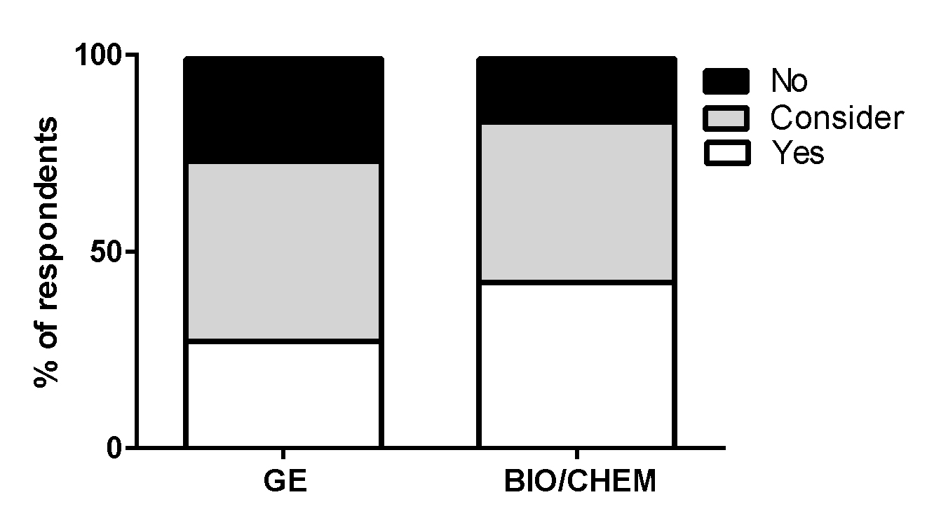

1. A total of **39%** said they would either “yes, very much” (16%) be interested in or ”strongly consider” (23%) completing an **environmental studies minor**.
   1. Biology/chemistry students were marginally significantly more likely to say “yes, very much” (22%) than GE students (13%) rather than simply “consider” or outright “no” than GE students.
      1. However, GE students were just as likely to “consider” it than Biology/Chemistry students (22% vs. 24%, respectively).

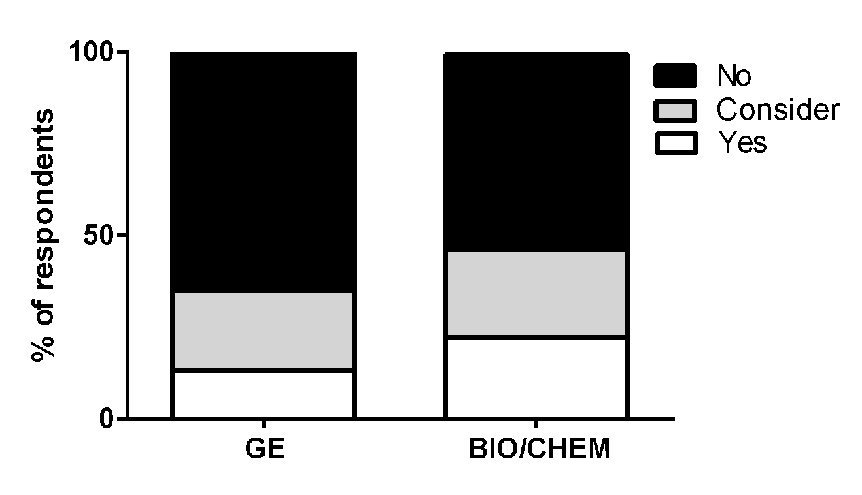

**Conclusions:**

* **The vast majority of students expressed interest in having more treatment of environmental studies in the Westmont curriculum.**
  + Interest appeared to be strong both within the sciences alone and in GE students from various disciplines (including the sciences).
* **Students expressed great interest in taking an introductory environmental studies course.**
  + Even if we consider only the students that responded that they were “yes, very much” interested in taking an introductory environmental studies course (33%), and extrapolate to the full student body, this would mean 99 students would be interested in taking the course each year. ***But realistically, even if we had only a fraction of these highly interested students enroll in the course, this would be more than sufficient interest to justify launching an introductory course.***
* **An impressive proportion of students expressed interest in an environmental studies minor.**
  + Even if we consider only the students that responded that they were “yes, very much” interested in completing an environmental studies minor (16%), and extrapolate to the full student body, this would mean 48 students per year completing this minor. ***But again, realistically, even if we had only a fraction of these highly interested students sign up for the minor, this would be more than sufficient interest to justify launching it.***

*Thanks to Marianne Robins, Lisa DeBoer, Alister Chapman, Steve Contakes, Beth Horvath, Bridget Quanstrom, and Amanda Silberstein for distributing these surveys to their classes!*

**ENVIRONMENTAL STUDIES SURVEY**

(1) What year are you at Westmont?

___ First-year

___ Sophomore

___ Junior

___ Senior

(2) Have you covered topics related to the environment/sustainability/conservation in any course at Westmont?

___ Yes

___ No

If so, which one(s)?

____________________________________

(3) Do you think there is a need for more treatment of environmental issues in courses at Westmont?

___ Yes

___ No

(4) If you were just starting out at Westmont, would you be interested in taking an **introductory environmental studies course** to fulfill a GE requirement if it were offered?

___ Yes, very much

___ I would strongly consider it   
___ No, not likely

(5) If you were just starting out at Westmont, would you be interested in completing an interdisciplinary **environmental studies minor** if it were offered?

___ Yes, very much

___ I would strongly consider it   
___ No, not likely

**Appendix 2. Status of Environment-Related Degree Programs at other Institutions**

|  |  |  |
| --- | --- | --- |
| **Institution** | **Christian** | **Environmental Science or Studies?** |
| Azusa Pacific | Y | none |
| Baylor | Y | both |
| Bethel | Y | both |
| Biola | Y | science |
| Calvin | Y | both |
| Concordia | Y | both |
| Eastern | Y | science |
| George Fox | Y | none |
| Gordon | Y | both |
| Loyola Marymount | Y | both |
| Messiah | Y | both |
| Pepperdine | Y | studies |
| Point Loma | Y | both |
| Seattle Pacific | Y | none |
| Taylor | Y | science |
| Thomas Aquinas | Y | studies |
| Wheaton | Y | science |
| Whitworth | Y | studies |
| Amherst | N | studies |
| Bowdoin | N | studies |
| Bryn Mawr | N | studies |
| Cal Lutheran | N | both |
| Cal Poly SLO | N | both |
| Chapman | N | both |
| Claremont McKenna | N | both |
| Cornell | N | both |
| Gonzaga | N | studies |
| Grinnell | N | studies |
| Middlebury | N | both |
| Pomona | N | both |
| Rice | N | both |
| Santa Clara University | N | both |
| Scripps | N | both |
| Swarthmore | N | both |
| UCLA | N | both |
| UCSB | N | both |
| UCSD | N | both |
| Williams | N | studies |

**Appendix 3. Letters of Support from Student Organizations**

March 7th, 2018

Dear Dr. Sargent,

As Westmont College moves forward as a leading Christian higher education institution, we are sure that refining our programs and tailoring them to the most current global movements is of utmost importance. We’re very excited to support Dr. Amanda Sparkman in her proposition to add an Introduction to Environmental Studies course and an Environmental Studies minor.

As Christians, we believe that God calls us to care for His beautiful Creation. In fact, this was the first task given to us by God in Genesis! The Environmental Studies course and Environmental Studies minor will be avenues through which to provide crucial education on the best ways to take care of Creation, both individually and corporately. We request that you would give full consideration to Dr. Sparkman’s proposition, as both items would be incredibly inspirational and necessary choices for Westmont College.

Sincerely,

The Westmont Garden Club

~~~~~~~~~~~~~~~~~~~~~~~~~~~~~~~~~~~~~~~~~~~~~~~~~~~~~~~~~~~~~~~~~~~~~

Ian Stephenson ‘18 (Garden & Sustainability Club President)

Kenny Chism ‘17 (Westmont Vegetable Garden Manager)

Audrey De Haan ‘20 (Garden & Sustainability Club Vice President)

Liam Whitfield ‘19 Billie Bioku ‘20 Maddie Weicht ‘20 Hanna Rose Kliewer ‘20

Jeffery Schiller ‘20 Zoey Boisen ‘21 Katie Bloom ‘18 Rachel Clyde ‘21 Léal Makaroff ‘19

Lyndall Stephenson ’20 Kennedy Mahdavi ‘19 Cassidy Tiegs ’21 Morgan Tucker ‘20

Kelly Evans ‘19 Caleb Rodriguez ’19 Lucy Aldworth ‘21 Dana Hjelm ‘20

Heidi Pullmann ‘19 Noel Hilst ’19 Alaina Haring ‘18 Kayla Monson ‘18 Katie Skiff ‘17

Hannah Belk ‘18 Nathaniel Johnston ’19 Ana Bulger ’19 Abby Gritter ’17

Tyler Ledbetter ‘19 Surin (Lori) Kim ’17 Heather Totten ‘19 Samantha Gee ‘20

April Harper ‘18 Grace Teranishi ’18 Hendrik Struik

March 29, 2018

Dear Dr. Sargent,

With each passing year, the world grows more complex and more dynamic. Westmont College, as an institution designed to foster young, promising Christian leaders, is in a unique position to participate in our constantly evolving surroundings. As international productivity and efficiency surges, preserving and studying the environment is more vital than ever. Environmental Studies stands as an increasingly prominent field, meriting the world’s attention—and ours. Here at Westmont, we often discuss the importance of our students being prepared to engage with and influence their surroundings. Naturally, learning about environmental issues, processes, and science would strengthen Westmont students’ practical, world-applicable expertise.

Furthermore, as stewards of God’s good creation, we are called to learn about, protect, and nurture the natural world. The Scriptures, especially Genesis, clearly assert that the Earth and its resources are gifts from God that He intended for responsible use. However, we must receive education about the natural world in order to properly play our role in the creation mandate. That is precisely why we, the members of the Student Environmental Awareness League, are thrilled to advocate for Dr. Sparkman’s Environmental Studies minor. We firmly believe that said minor would provide a unique, much-needed facet to Westmont and advance our mission to cultivate maturing Christian minds.

We unequivocally endorse Dr. Sparkman’s proposal and respectfully urge you to consider implementing it. Thank you for your time; we eagerly await word of your decision.

Regards,

The Student Environmental Awareness League

~~~~~~~~~~~~~~~~~~~~~~~~~~~~~~~~~~~~~~~~~~~~~~~~~~~~~~~~~~~~~~~~~~~~~~~

Karis Cho ‘21 (Head of Club Communications)

Jeffery Schiller ‘20 (Club President)

Olivia Stowell ’19 Rachel Elliott ’21 Zoey Boisen ’21 Simon Janzen ’21 Emily Herbst ‘2121

Sierra Farrar ’19 Madelyn Olaerts ’19 Milán Barrero ‘21 Elaina Hollister ’21

Brenna Ritchey ’19 Brennan Confer ’21 Isabel Mata ’18 Nate Sirovatka ’21 Toni Ramirez ‘21

Winston Gee ’21 Samantha Martin ‘19

**Appendix 4. Logistical Details for Environmental Studies Minor Courses**



**Appendix 5. Preliminary list of local organizations with internship opportunities for Westmont students**

***(This list is still growing!)***

|  |
| --- |
| Channel Islands Restoration |
| City of Santa Barbara Environmental Services |
| City of Santa Barbara Recycling |
| City of Santa Barbara Water Conservation |
| ECOFaith of Santa Barbara |
| Gaviota Coast Conservancy |
| Growing Solutions |
| Marine Mammals Rescue/Rehab Center |
| Santa Barbara Audubon Society |
| Santa Barbara Botanic Gardens |
| Santa Barbara Channelkeeper |
| Santa Barbara Natural History Museum |
| Santa Barbara Sea Center |
| Santa Barbara Zoo |
| The Trust for Public Land |
| Westmont Garden |
| Wilderness Youth Project |