2017-2018 Oral Communication ILO report
Lesa Stern, John Moore, Marty Asher, and Tim Wilson
ILO Assessment Team

Oral Communication ILO

Message construction: This outcome measures how well students devise, prepare, and create messages, focusing primarily on thesis statements, key arguments, and supporting evidence. Message construction should also be evaluated for its contextual appropriateness.

Delivery skills: This outcome emphasizes the performance aspects of speech acts, primarily quality of voice (tone, pitch, rate, etc.) as well as physical presence (eye contact, gestures, posture, appropriate appearance, and energy).

Audience-centeredness: This outcome assesses student sensitivity to the audience and occasion. Audience-centeredness includes responding well to challenging questions, respecting intercultural differences, and handling unforeseen situations. This skill is based on good listening and responding to others in ways that foster community and minimize erroneous assumptions.

Overarching Goals for Oral COM ILO Team

1. To create a rubric based on the Oral Communication ILO criteria provided to us by the College.

2. To provide seminars for faculty that will help them with teaching and assessing oral communication
- provide a seminar on teaching oral com
- provide a seminar on how to use the Oral COM ILO
- provide a seminar that helps faculty create oral communication assignments (& corresponding handouts for their students)

3. To create a digital space to gather Oral Communication resources for faculty

4. For Faculty to have meaningful discussions (within & between depts):
  - what Oral COM competencies do they want for their majors?
  - what are they doing (in their depts) to promote oral communication competency?

5. To identify meaningful presentations taking place across the campus & have faculty and student life evaluate those presentations via ILO rubric.
  - Senior projects/capstones, research presentation days, honors presentations, student government election speeches, etc
  - Gather internship supervisor evaluations of oral com

6. To provide meaningful feedback to departments & the college based on the data (from the presentations assessed via the rubric)

Implementation of Assessment plan

1. Create a Rubric for the 3 Oral Com criteria
The ILO team spent Sept and Oct reviewing various oral communication rubrics and then created 2 rubrics (one simple, one more complex) for the ILO criteria provided to us by Dr. Nazarenko (see Appendix A). The 2 rubrics were discussed at 3 department chairs’ meetings and the chairs voted on which one to use; the more complex rubric was unanimously chosen (see Appendix B). Faculty “buy in/ownership” of the rubric was important to the assessment process. Chairs were briefed on how to use the rubric and questions were answered at this time.

2. Seminars provided for faculty/staff (help with teaching and assessing oral communication)
- During Fall semester, Greg Spencer (Communication Studies professor) offered 3 sessions (90 min each) of “communication principles for teaching oral communication” attended by 35 faculty members.
- Spring semester, Elizabeth Gardner (Communication Studies assistant professor) offered 3 sessions (75 minutes each) of “Rubrics: Making our way to Common Ground” to help all faculty use the ILO Oral COM rubric well. Target audience: faculty who are teach a capstone /class w/ seniors that also include an oral presentation. Ten faculty attended this workshop.
- Spring semester, Lesa Stern (Communication Studies professor) offered 3 sessions (90 minutes each) on “Creating/Revising Presentations Assignments and Handouts” to help faculty articulate clear goals for their oral presentations and clear rubrics for each of those goals (various rubrics are located on the Oral COM ILO Canvas site and a spiral bound paper copy was used during these workshops). Ten faculty attended this workshop. Each Department chair was provided with a spiral bound copy of various rubrics that may pertain to what faculty might incorporate in their presentation assignments (faculty can look thru these rubrics and use or modify them for their own assignments). The handout used in this workshop was also uploaded to Canvas (see Appendix C).

3. Repository for Oral Communication resources
Lesa Stern created the Canvas course “Oral Com ILO” that explained the ILO and the assessment process for 2017-2018. This site also included numerous resources related to oral communication for faculty to refer to over time (beyond the assessment). The Oral Com rubric, assigned “shepherds” for departments, seminar times (and videotape links to 2 of the seminars if faculty could not attend any sessions) were all provided on this canvas site in Fall 2017. (See Appendix D)

4. Meaningful Discussions within departments
During the department chairs’ meetings in Fall semester, Lesa provided all chairs with a copy of “Conversations Starters for Departments” (see Appendix E) that could guide their department conversations. Lesa also asked the chairs to provide feedback on their conversations to the ILO team. The goal of meaningful all-department discussions was partially met, in that six departments did devote substantial time to discussing oral communication and completed a department conversation starter summary. However, due to the fire and mudslide and subsequent evacuations, several departments did not find the time to have these conversations and chose to push them back to the following year. On another positive note, many conversations within departments and between departments took place on a more informal or interpersonal level. Some of these discussions took place during the seminars.

Tim Wilson was selected for the team because he has guided the assessment work in the Student Life Division. We recognize that many of our student life staff have significant contact with and are in position to give feedback to students who are making oral presentations. Tim shared the rubric that was developed to assess the 3 Oral Communications Criteria with the Student Life Leadership Team (SLLT). The SLLT meets weekly and consists of Edee Schulze, Vice-President; Stu Cleek, Dean of Students; Angela D’Amour, Director of Campus Life; Jason Cha, Director of Intercultural Programs; Paul Bradford, Director of Career Development & Calling; Ben Patterson, Campus Pastor; Shannon Balram, Residence Life. The SLLT decided to use the rubric to give feedback to student leader candidates as they delivered election speeches for the various leadership roles on campus. Angela D’Amour created a leadership development competency tool (see Appendix F) that includes the Oral Communication ILO. Next spring the rubric may be used to give feedback to baccalaureate speakers as they practice their talks.

5. Identifying presentations across campus by seniors and having departmental faculty take ownership of assessment.
We were very pleased with the implementation of this goal. The ILO team identified existing presentations (by seniors) within courses. We did not want to have any assignments constructed artificially for this assessment, as one of the hallmarks of good assessment is accessing embedded assignments of value. We assumed that if faculty were requiring a presentation (often within a capstone course), then it was of value to the faculty of record and the department. We used the information provided by the Dean of Curriculum and Educational Effectiveness as a starting point (see Appendix A). Shepherds contacted each of the department chairs and faculty of record for capstones with known presentations about participating in the assessment.

Faculty took ownership of the oral communication assessment by using the newly created ILO rubric to evaluate their seniors’ presentations. Shepherds also answered questions and trained faculty on the ILO rubric (who could not make the rubric/norming presentations).

6. Provide meaningful feedback to departments and college based on the data collected.
Lesa Stern provided department chairs with a summary of their own department’s oral communication rubric evaluation (percentages for each criteria for each level of evaluation). We hope the departments will reflect on these results from just their own senior majors and consider what steps their department wants to take in improving their students’ oral communication.

2017-2018 Presentation Assessment
Data collection
Of the 279 graduating seniors, we hoped to assess all those who gave a presentation this year. One hundred and fifty-nine (159) senior student presentations were evaluated and submitted by 11 different departments. Fifty-seven percent of graduating seniors were evaluated on the Oral Communication ILO rubric. This sample is a robust sample in both breadth of students (a variety of different departments from all 3 divisions in the college) and size. All faculty utilized the same, clearly defined rubric and were provided with training on it (3 live group training sessions and an on-line training video to consult) as well as individual consultations with Dr. Gardner and each of the Oral Communication Assessment team to make sure that everyone understood how to use the rubric and to get any clarification needed.

Of those departments who did not participate, some departments did not have any required presentations of their seniors and others did not do so because of course changes to the schedule due to the fires, mudslide, and the evacuations that took place.

Data processing
All paper rubrics were collected and scanned to pdf for electronic storage. The data from the rubrics was then entered into SPSS (statistical package) for analysis. Any criteria (box) that was not applicable was left blank by the faculty evaluators, and therefore shows up as “missing data” in the computer file. When evaluators marked on the line between excellent and good/fair, then the score was entered as 1.5; and if between good/fair and unsatisfactory, it was entered as a 2.5. We retained the actual scores used by departments in the original data file. However, for summary percentages for all the college, the half scores were attributed to the lower category. Percentages reflect the actual (valid) number of presentations that scored in each category.

Summary Table Results of Evaluations of Oral Presentations
Percent of Speakers who scored excellent, good/fair, or unsatisfactory
for each oral communication criteria

Oral Com Competency |  | Excellent | Good to Fair | Unsatisfactory
Message construction:  This outcome measures how well students devise, prepare, and create messages, focusing primarily on thesis statements, key arguments, and supporting evidence. Message construction should also be evaluated for its contextual appropriateness. | Message  Thesis  Argument  Evidence | 50 | 42 | 8
 | Organization | 51 | 43 | 6
 | Language | 45 | 53 | 2
Message Construction overall rating: |  | 49 | 47 | 4
Delivery skills: This outcome emphasizes the performance aspects of speech acts, primarily quality of voice (tone, pitch, rate, etc.) as well as physical presence (eye contact, gestures, posture, appropriate appearance, and energy). | Vocal | 50 | 44 | 6
 | Physical | 47 | 48 | 5
 | Holistic | 55 | 42 | 3
Delivery overall rating: |  | 46 | 49 | 5
Audience-centeredness:  Oral communication should demonstrate sensitivity to the audience and occasion. Audience-centeredness includes responding well to challenging questions, respecting intercultural differences, and handling unforeseen situations. | Sensitivity to audience & occasion | 53 | 41 | 5
 | Q & A time | 57 | 41 | 3
 | Adapt to audience | 61 | 37 | 2
Audience-centeredness overall rating: |  | 60 | 39 | 1
Notes: any criteria that was not applicable was left blank. Percentages reflect the actual number of presentations that scored in the category. Some evaluators marked on line between two categories; the score was attributed to the lower category. Some evaluators only completed the “overall rating” and did not mark the sub-criteria, thus explaining why the percentages in the overall evaluations do not necessarily match the sub-criteria percentages.
Note: 159 senior student presentations were evaluated by 11 different departments

Interpretation of results
- The committee was pleased to see that 95% of presentations were evaluated as good/fair or excellent.
- The percent of students receiving the excellent score (60%) was markedly higher in audience centeredness than message construction or delivery.
- Although relatively few students were evaluated as unsatisfactory, some work could be done in improving the message, thesis, argumentation, & evidence skills (8% unsatisfactory)

Internship Supervisor Evaluations

Data collection: Additional data was collected in order to assess how well students communicate orally in the workplace outside of Westmont. Supervisors complete evaluations related to many different aspects of workplace performance and attitudes. Two performance elements relate to oral communication: (1) Listens actively and attentively and (2) demonstrates effective verbal communication skills.” Data related to oral communication was taken from 50 supervisor evaluations of interns during Spring 2018 (see table below).

Results and Interpretation of data: Data reveal that most interns are perceived to be active/attentive listeners (98%) and most (94%) are exceptional or commendable with their oral communication. Supervisors seem well pleased with all but a couple interns’ oral communication skills.

Summary Table of Supervisor Evaluations of Interns’ Communication Skills
Percent of interns for each oral communication rating by supervisors

 | Exceptional | Commendable  (exceeds expectations) | Fair | Uncomplimentary | Unsatisfactory
Listens actively and attentively | 72 | 26 | 2 | 0 | 0
Demonstrates effective verbal communication skills | 58 | 36 | 4 | 2 | 0
n=50 from multiple departments across campus

Oral Communication ILO Recommendations
based on the assessment conducted 2017-2018

- During 2018-2019, the departments who did not have an oral communication conversation (see “conversation starters” handout in appendix) do so and report back to the PRC. We would like to know what departments need in order to improve oral communication within their majors.
- For each department to spend a portion of a department meeting discussing the results of this Oral Communication ILO assessment.
- Faculty use of the ILO oral com rubric or their own rubric that is tailored to their specific oral com presentation with students. We believe there is value in presenting (a teaching component) and using this rubric (or their tailored rubric) with students at all levels. Rubrics help set clear expectations for presentations.
- At the beginning of each school year, Dean of Curriculum and Educational Effectiveness remind faculty of the oral communication ILO rubric as well as the canvas site that is a repository of helpful rubrics and guidelines for oral communication.
- The ILO team was pleased that most students (95%) performed good/fair or exceptionally. However, it might be helpful for the college to set a “benchmark” for oral communication.
- PRC/Dean of Curriculum and Educational Effectiveness to provide support to faculty and staff who wish to improve how they teach oral communication.
- For the newly emerging Center for American Democracy, we recommend considering an oral communication component as oral communication and civility are important elements of a democracy.
- Celebrate the good oral communication skills of our seniors! The internship supervisors, who spent around 144 hours with each student over the course of the semester, were very pleased with how our seniors are communicating.

Recommendations/reflections related to the assessment process
- Some faculty only used the “overall rating” for the 3 criteria when completing the rubric. Having all faculty mark the sub-criteria would help departments see where they need to improve within each area.
- During the rubric development stage, we discussed the value of using a 3 category scoring system verses a 4 category system (that splits out good and fair). On one hand, more detailed information provided by a 4 category system might be helpful. However, based on research in the communication discipline, this 4 category system typically has low inter-rater reliability. Therefore, we chose the 3 category system so that we would have more reliable use of it, especially across disciplines/departments.

Reflection on assessment process/data collection
Seminars and conversations. The committee was adamant about this assessment being owned and supported by the faculty. On that goal, we feel the process of assessment was very strong. Chairs selected and gave feedback on the rubric and the process by which data would be collected. We had chair “buy in” to the process. Despite the fire and mudslide (and the tumult of the semester) we were pleased that many campus seminars (for faculty and staff) and department conversations revolving around oral communication took place.
Faculty participation in the assessment process. We were very pleased that faculty across 11 different departments used the rubric on 159 senior presentations. Over 57% of graduating seniors were assessed!
Canvas ORAL COM ILO Course. We think this canvas course is a good resource for faculty to access when they assign student presentations, rather than just for assessment.

Appendix A: Oral Communication Competencies
provided by Tatiana Nazarenko in summer 2017

The Gen Ed Committee would like to know in which required course(s) in your department the following evidence of student learning can be collected:
1. Message construction: This outcome measures how well students devise, prepare, and create messages, focusing primarily on thesis statements, key arguments, and supporting evidence. Message construction should also be evaluated for its contextual appropriateness.
2. Delivery skills: This outcome emphasizes the performance aspects of speech acts, primarily quality of voice (tone, pitch, rate, etc.) as well as physical presence (eye contact, gestures, posture, appropriate appearance, and energy).
3. Audience-centeredness: This outcome assesses student sensitivity to the audience and occasion. Audience-centeredness includes responding well to challenging questions, respecting intercultural differences, and handling unforeseen situations. This skill is based on good listening and responding to others in ways that foster community and minimize erroneous assumptions.
Department | Course(s) | Comments
Art | ?
Biology | BIO-195; BIO-196; BIO-197 | x
Chemistry | CHM-195: Chemistry Seminar
Communication Studies | COM-101: Theories of Rhetoric and Communication | x
Computer Science | CS-195 | x
Economics & Business | EB-195 | x
Education | ED-100; ED-101; ED-105 | x
English | ENG-192: Capstone Seminar
History | HIS-198: Senior Research Seminar
Kinesiology | KNS-166: Movement: Pedagogy and Leadership
Math | MA-180 | x
Modern Languages | SP-150/FR-150: Cross-Cultural Studies
Music | MU-121: Music History
Philosophy | PHI-195: Senior Seminar
Physics | PHI-195: Senior Seminar
Political Science | POL-040: Empirical Political Research
Psychology | PSY-198
Religious Studies | RS-180: Senior Seminar
Sociology/ Anthropology | SOC-197/ANT-197
Theatre Arts | TA-193: Senior Project | x

Appendix B: Westmont’s Oral Communication ILO rubric

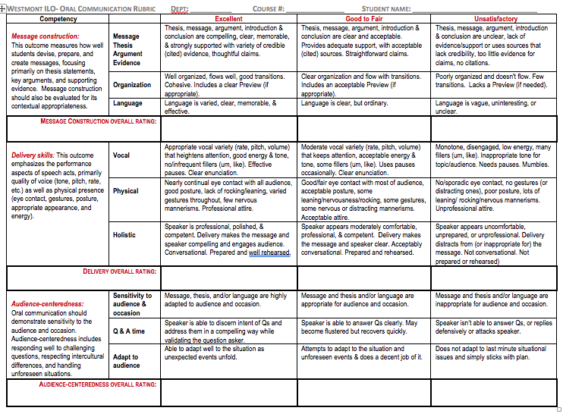

Appendix C
Oral Communication ILO: Constructing an assignment/student handout

1. What 3 things do you want students to practice and to do well in this presentation?
*

*

*

2. Do you have a rubric or handout that articulates the specifics of what you expect?
If not, then look thru the rubrics provided…do any pieces of these rubrics capture elements of what you want? (You can mix and match different criteria from the different rubrics and also create some of your own criteria)

3. Share the rubric with the students when you introduce the assignment. Have a discussion to clarify. Show an example of a good presentation and process w/class what was good and what needs work.

4. Require an outline that forces students to plan the presentation (Otherwise they often “wing it”).
Provide feedback & discussion over their rhetorical choices in their outline (argument, structure, transitions, etc).

5. Do they practice the speech and receive feedback before their actual graded speech?
This can be an assignment where you have peers use the rubric or handout to provide feedback a few days before the actual speech (outside of class time) such that the speaker has time to modify speech

Other things to think about when designing Presentations

How does this presentation fit into the larger picture of ALL the presentations students encounter in the major
Ex: If this is their first presentation, start with basics or focus on just a few things you value. However, if prior presentations, you can focus on more sophisticated skills

Faculty instruction ideas
- teach them in class how to construct their presentations
- provide handouts or reference materials for them to follow/review
- provide examples (excellent presentations & outlines) so they can see what you expect from them

Appendix D: Screen Shot of Canvas Course (Oral Communication ILO) Elements

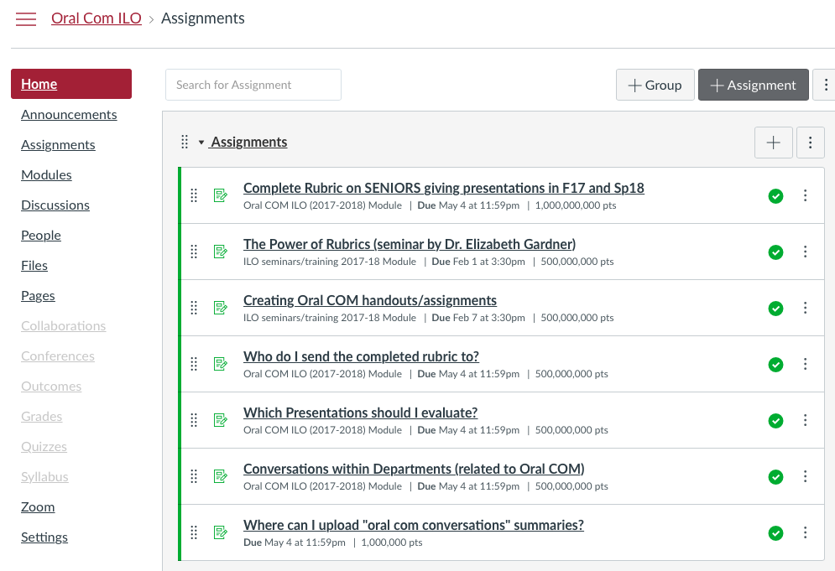
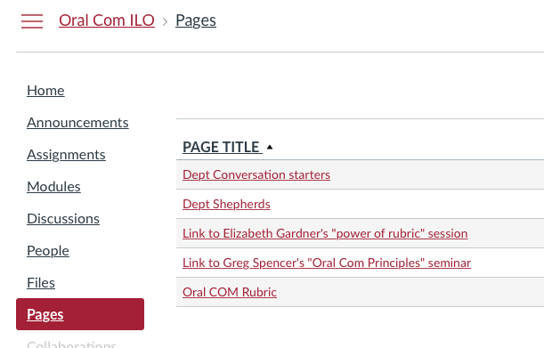

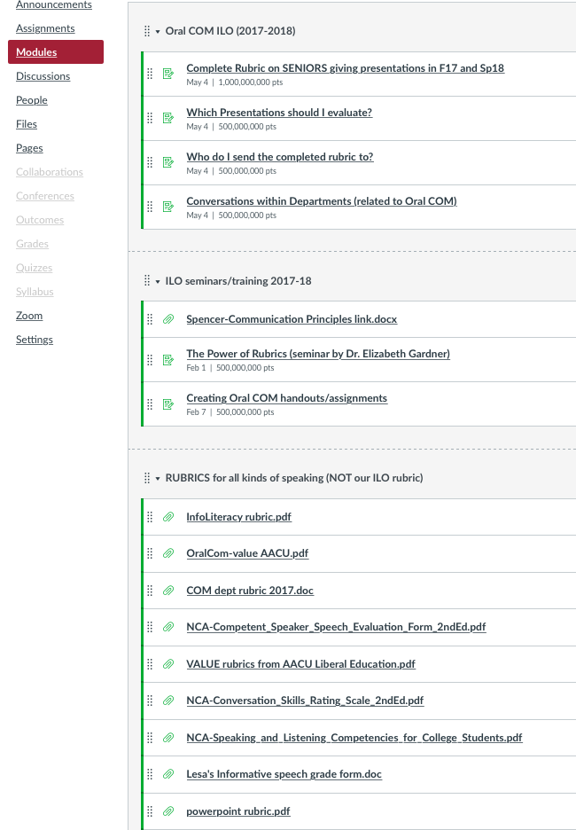
Appendix E: Conversation Starters for Departments
Oral Communication ILO

(Values & Vision-casting of goals)
1. What oral communication knowledge/ skills/ attitudes do you want to see your majors graduate with?
What is valuable for professional life?
What is valuable for community or faith life?

(Teaching)
2. What kinds of oral com teaching are you currently doing in your classes?

(Practice w/ Feedback)
3. What kinds of oral com assignments do you have in your classes?

(Congruence between Values/Goals and teaching/assignments)
4. Do the teaching and assignments (across all classes in your major/dept) ultimately reflect the skills you want from your graduates?

5. If they are not getting the oral com skills/knowledge from the major/dept, are there other places they are developing these skills (in a rigorous or consistent way?)

-------------------------------------------------------------------------------------------------------------------
Review the Oral Communication ILO & criteria below (approved by senate and GE committees).
- Message construction: This outcome measures how well students devise, prepare, and create messages, focusing primarily on thesis statements, key arguments, and supporting evidence. Message construction should also be evaluated for its contextual appropriateness.
- Delivery skills: This outcome emphasizes the performance aspects of speech acts, primarily quality of voice (tone, pitch, rate, etc.) as well as physical presence (eye contact, gestures, posture, appropriate appearance, and energy).
- Audience-centeredness: This outcome assesses student sensitivity to the audience and occasion. Audience-centeredness includes responding well to challenging questions, respecting intercultural differences, and handling unforeseen situations. This skill is based on good listening and responding to others in ways that foster community and minimize erroneous assumptions.

Are these Oral COM criteria valued in your department?
How are you developing these criteria in your students?

Appendix F: Leadership Development Competency Catalogue 2018
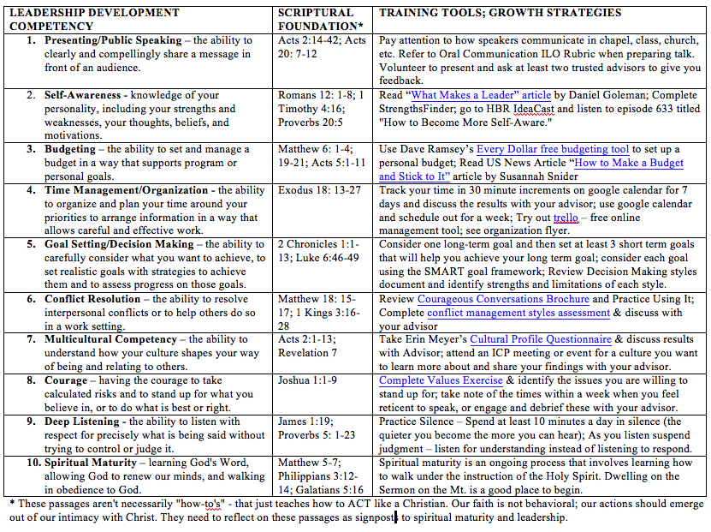

In addition, two additional departments evaluated senior presentations and provided feedback to their students (39 in one department on their own rubric, such that we couldn't include their data here, and 10 in another department that lost the completed rubrics before submitting them.) If you include these seniors, 208 graduating seniors (75% of the graduating class) completed a presentation and received feedback on their performance.

