

Independent Living Resource Center (ILRC)

Best Practices For Creating Accessible Community Events


Acknowledgments
This research was made possible by a grant from the Fund for Santa Barbara to the Independent Living Resource Center (ILRC). We would like to thank all our colleagues from ILRC for their support and assistance on our workshop. We also want to thank all contributors to our research for this guide for their insights, wisdom, and suggestions.

Table of Contents
Types of Disabilities and Best Practices at Events 4
Mobility Disabilities 4
Non-Visible Disabilities and Mental Health Diagnoses 4
Deaf and Hard of Hearing 5
Blind and Low Vision 6
General Tips and Recommendations for Accessible Community Events 7
Examples of Accessible and Inaccessible Flyers 9
Table of Comparison 12

Types of Disabilities and Best Practices at Events:
- Mobility Disabilities
- Non-Visible Disabilities and Mental Health Diagnoses
- Deaf and Hard of Hearing
- Blind and Low-Vision
I. People with Mobility Disabilities
- The venue must provide spaces for wheelchair users with an accessible route. If the wheelchair spaces are not needed, removable seats can be used in that area.
- Aisles and paths to seating areas, bathrooms, refreshment and information tables should be ADA complaint for wheelchair accessibility (32-36” wide)
- Aisles should remain clear at all times
- Accessible seating should be integrated throughout the whole venue if possible
- There should be accessible restrooms at the event
- Parking lots should have accessible parking spots
- There should be a clear path of travel from bus stops and parking lots to the assembly area
- Doors must be ADA complaint and wide enough to fit mobility devices (32-36” wide)
- No merchandise or objects should be placed in front of doors, as more clearance is needed for mobility devices

II. People with Non-Visible Disabilities or Mental Health Diagnoses
- Do not point out or say a person’s diagnosis without their consent
- Be aware that people with non-visible disabilities may need accommodations
- Do not assume a person will act a certain way because of their disability or mental health diagnosis
- Indicate on the flyer if flashing lights or extremely loud noises will be used at the event
- Try to provide breaks when an event is longer than 1 hour and a half
- Meeting areas should be fragrance free
- Sometimes persons may need to move, stand or fidget to stay engaged
III. Deaf and Hard of Hearing
- When speaking to someone who is Deaf or hard of hearing, speak to the person not the interpreter
- Make sure to build in break times for the interpreter if there is only one interpreter present at the event
- Make sure captioning is present if requested
- Do not assume all people who are Deaf can sign or read print
  - Please check with the person to see what their communication preferences are
- Please allow more time for Deaf/ hard of hearing persons to make presentations or public comment to accommodate for communication facilitation
- To applaud, wave your hands above your head to show appreciation for Deaf presenter, rather than clapping
- Remember that according to the ADA, an “assistive listening system shall be provided” in public venues
IV. Blind and Low Vision
- Handouts should be provided in either large print (minimum of 14 point), Braille or in an electronic format as a text document depending on the preference
- Make sure all documents that have images are captioned (i.e a text explaining what is happening in an image) so they can be read by screen reader
  - A “Screen Reader” is a type of software program that allows people who are blind or visually impaired to read by converting documents and text into a synthesized speech or Braille
- When creating handouts, announcements, etc, avoid using PDF’s. because they cannot be read by most screen readers
- Make sure the assembly area has adequate lighting
- When showing pictures during a meeting, please describe the picture
- All cords and wires in the assembly area should lie flat on the floor to prevent hazardous tripping
- When sending out handouts please send two copies; one original copy and one “text only” version without graphics so it can be read properly

General Tips and Recommendations for Accessible Community Events ::
- Make sure that promotional materials for the event include the following information:
1. Accommodations can be made if needed and provide a contact number, and e-mail . (Do not assume that everyone knows accommodations can be made, if it is not listed on your flyer.)
2. That the event/meeting is in an accessible location
- community events in spaces where people with disabilities frequent
- Make sure to communicate effectively with people who cannot attend. (i.e. making sure the information is online and easily accessible.)
- Find community leaders within organizations to share the information with (i.e. ILRC). Also make sure to share the information on social media, radios and \newspapers.
- Make sure accommodations or contact information for needing accommodations is clearly indicated on the meeting announcements
- Most cities allow requests for accommodations up to three business days before the event.
- The location of a meeting should be accessible to all persons IE. close proximity to public transport)
- The start times of meetings should be late enough that people who ride the bus or need assistance in getting ready for their day are able to attend
- Sign Language interpreters can be found and requested at ILRC website http://www.ilrc-trico.org/services/deafservices.html
- Text captioning services can be found by contacting Diane Brandin Realtime Captioning at http://dianabrandin.com/contact-us---services.html
- Where to get documents translated and converted into Braille (grade 2) can be found here
    - Braille Institute http://www.brailleinstitute.org/santabarbara.html
    - http://production2print.com
    - http://www.atpc.net
    - http://www.signarama.com/ca-santa-monica-west
- All meetings should have some type of greeter/ welcome committee for questions regarding the meeting, seating, etc.
- *Reminder* that service animals are allowed by law at all public meetings
Examples of Accessible and Inaccessible Flyers

Free Workshop for New Business Owners
August 6th at 8 am

“Get the insider scoop on how to make your business thrive”

It’s your time to shine!
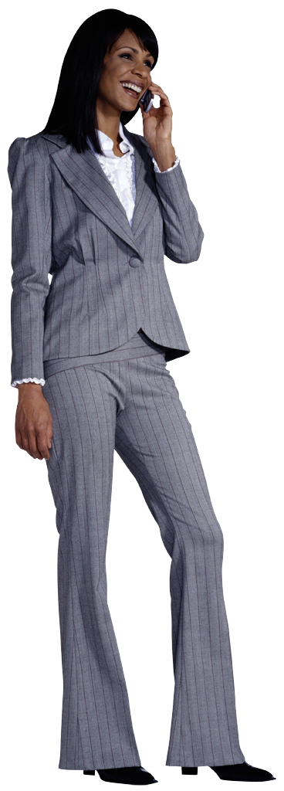
In two hours we will not only help you understand the basics, but we will make sure you are on the right track to success. Plus guest speaker, Bianca Lane, will
share her story on how she turned her business into a global organization.

Register now at
www.businessthriveLane.com
Check in at 7:40 am

Location: Natural History Museum
2599 Puesta Del Sol, Santa Barbara 93105
Free Workshop for New Business Owners
August 6th at 9:30 am

“Get the insider scoop on how to make your business thrive”
It’s your time to shine!

In two hours we will not only help you understand the basics, but we will make sure you are on the right track to success. Plus guest speaker, Bianca Lane, will
share her story on how she turned her business into a global organization.

Register now at
www.businessthriveLane.com
Check in at 9:00 am

If accommodations are needed please contact Jeffrey at 1-800-556-6556 or jlagos@businessthrivelane.com by August 4th
Figure 1: A businesswoman on the phone

Accessible Location: Santa Barbara Library
40 E. Anapamu St., Santa Barbara, CA 93101
Differences Between Flyer A and Flyer B when creating Accessible Handouts
Flyer A | Flyer B
- Not at an accessible location because buses don’t run in that area  - There are no captions for graphic images  - Start time and check in time is extremely early  - There is no section saying accommodations can be made, therefore the person does not know | - The event is at an accessible location  - The flyer clearly indicates that it is at an accessible location  - All graphic images contain a caption  - A later start time and check in time allows for any types of transportation difficulties  - There is a section that clearly states accommodations can be made upon request, who to contact, and by when  - Font is big enough to be read by anyone with visual impairments  - The flyer is more inclusive allowing all types of people to participate if they would like

